# Problem

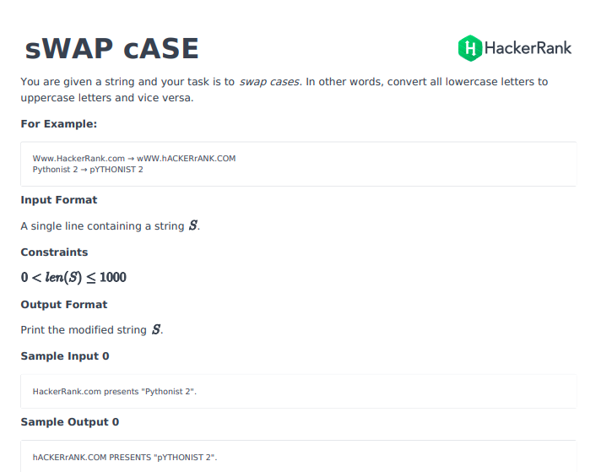

# Solutions

## Python3

def swap_case(s):

return s.swapcase()

### Pypy3

def swap_case(s):

result = []

for letter in s:

if letter == letter.lower():

result.append(letter.upper())

elif letter == letter.upper():

result.append(letter.lower())

else:

result.append(letter)

return ''.join(result)